Instructions

You are to divide the class between the different characters. Mr. Railroad and a team of managers consist of 5-10 students. Arbitrators consist of approximately 5 workers. The remaining students are workers. You may encourage them to create posters if they chose to go on strike. This activity will take a class period for the students to develop a plan and negotiate. When they are completed then debrief. By asking the following questions:
- What decisions did you make?
- Why did you make those decisions?
- Were there any other options you could have made? If so, what?
- Any other ideas about the activity?

Let the students have fun with this activity.

The Characters

Mr. Railroad and managers of the company (work with Mr. Railroad as part of the advisory team) - it is your responsibility to determine how you can keep expenses down and meet your financial obligations. You must determine how you will/will not work with the employees.
Workers – Your job is to decide what you will do then to approach the owner/managers with your proposition.
Arbitration team (5 students) – Your assignment is to learn the issues of the case. Be prepared to give an unbiased opinion to resolve the conflict should you be asked to help.

Background Information

The country has experienced a surge of immigration therefore the cities have experienced a rise in population. Which dramatically increased the work force. In the cities workers live in tenement houses and unsanitary conditions. Poverty and alcohol is a problem in the immigrant neighborhoods. Children, women and men are all working some in very unsafe conditions for pennies a day.
Amidst this environment there is a rising social movement among the middle class to improve the working conditions and clean up the tenement housing. There is a concern about the unsanitary work and home environment as well as the problem of alcoholism among the immigrant workers.
Among the workers there is a growing interest in labor unions. Business owners do not like the unions and do all in their power to break up the unions if/when they attempt to organize in their businesses. Many of the union organizers an avowed Socialists and believe they have the solution to the problems that arise from capitalism. Many workers believe their employers will not take them seriously if they do not organize. Many of these unions are employing the strike (walk out of the company and refuse to work until the problem is resolved) as a means of negotiating with employers.

Mr. Railroad

Mr. Railroad owns the Palace Car Company. The Palace car is a state of the art passenger car. It is very luxurious. These cars make traveling by trains very comfortable.
Mr. Railroad decided to move his company from the city and all its problems and build a planned community. This community is built around his business. You have built houses for your workers but you do require that the worker maintain the houses. To ensure the houses are kept properly you have inspectors who check the homes for cleanliness.
The community has a company doctor, library, church (non-denominational), hotel (employees can’t stay there), market and no bars/saloons. The town is built to be the ideal middle class town.
Mr. Railroad invested $2 million in the construction of the village and the adjoining factories. He promised investors they would have a 6% return on their investment in the village. Since the economic depression hit he has only been able to pay 3% on the investment.
Since you lease your railroad cars to the railroad companies it is your responsibility to maintain the cars. This includes painting, woodwork, upholstery, and iron/steel components.
Since the recent panic you are losing money on your current contracts in order to pay current wages of your workers. To remain in business you must make some concessions or you will not be able to remain a viable competitor.
To meet your financial obligations over the last year you have slowly reduced your employee’s wages. Now your employees are upset. They are requesting to meet with you. Will you meet with them or have your managers meet with them?
What will you do?
Your largest expense is wages.
You must provide dividends for your stockholders.
You must fulfill your contracts.

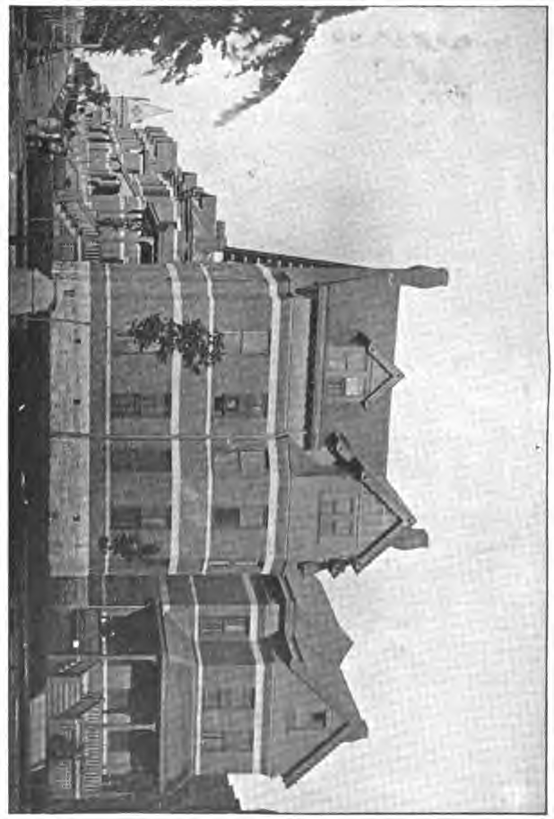

Workers
You live in a town owned by the company that employs you. The house you live in is nicer than you could get in the city. The company owns the house you live in. The company does not sell property in town. Therefore, you pay rent to the company. When you cash your paycheck the bank will collect your rent. The company maintains your home at no expense to you. The company manages the businesses in town; therefore, the company is able to control the price of goods.
The company provides a doctor to employees. If you are injured on the job the doctor could be called in to testify about your injury in any dispute with the company. The doctor appears to be honest and has not betrayed any doctor-patient confidences.
The company has experienced some financial setbacks as a result of the recent stock market crash. In an effort to maintain their responsibility to their investors and to fulfill their contracts the company has decreased wages across the board three times over the last year resulting in a total of two-thirds (2/3) wage reduction for all employees. Along with the wage reduction your hours have been cut as well. See the chart. In addition the managers have been very strict and demanding with the workers.
In the city many workers including railroad are organizing and joining unions. The idea is that a union representing a large faction of the employees will have a greater influence with the management/owners of a company. You and your fellow workers have been approached about joining the Railway Union, but you have not made a decision. Today some of the workers are concerned that the company may have another wage cut. There is a meeting to decide what you will do.
What will you do?
You can continue to tighten the belt until the economy gets better.
You can meet with your employer about your concerns.
You can start a union, but what will the union do for you?
You must make a decision and be able to explain why you came to that decision.

Wages for the Year of Discontent

Inside Finisher Painter Car Builder Seamstress
Date | Hours | Amount | Hours | Amount | Hours | Amount | Hours | Amount
May | 252 | $78.00 | 244 | $65.66 | 196 | $47.42 | 235 | $39.85
June | 280 | 96.85 | 241 | 65.28 | 92 | 21.00 | 212 | 31.24
July | 233 | 69.12 | 216 | 57.05 | 170 | 38.75 | 181 | 27.72
August | 244 | 62.75 | 242 | 65.14 | 173 | 36.91 | 197 | 30.18
Sept. | 167 | 44.77 | 232 | 62.62 | 94 | 21.50 | 147 | 23.90
Oct. | 114 | 26.92 | 230 | 62.04 | 42 | 7.39 | 230 | 34.62
Nov. | 119 | 29.05 | 125 | 32.58 | 91 | 20.54 | 151 | 24.39
Dec. | 229 | 43.85 | 52 | 12.52 | 140 | 18.37 | 180 | 28.18
Jan. | 261 | 49.30 | 279 | 66.84 | 192 | 34.00 | 216 | 24.21
Feb. | 238 | 44.95 | 227 | 51.00 | 240 | 60.00 | 184 | 25.47
March | 262 | 51.53 | 254 | 51.12 | 125 | 30.80 | 212 | 24.92
April | 185 | 37.77 | 226 | 48.63 | 60 | 9.00 | 197 | 22.14
Total | 2,588 | 634.86 | 2,572 | 641.19 | 1,616 | 345.68 | 2,345 | 346.82

