Title of lesson: Causes of WWI, The Great War Lesson One

Authors of lesson: Ryan Kaden, Nancy Ohmart, Janet Parker

Grade level: Middle School (Janet’s is elementary level and is in its own format)

Resources: Butter Battle Book, attached handouts

Lesson Summary: Students will participate in four activities that examine the four causes of WWI: Colonialism, Nationalism, Militarism, and Entangling Alliances. The colonialism activity asks students to play the role of European powers as they each carve out colonies in Africa. As the competition for colonies heats up, students realize how that competition led to war. The militarism activity asks students to read Dr. Seuss’s Butter Battle Book. As the Yooks and Zooks try to outdo one another, students realize that as nations build weapons, there is a lot of pressure to USE those weapons. In the entangling alliance activity, students role play to see the consequences of the alliance system that Europe built up prior to WWI. In the nationalism activity, students discuss what a terrorist is and what nationalism is. Students then examine 5 famous (or kind of famous) world leaders and classify them as a nationalist or terrorist. After classification of the leaders, class discussion ensues.

Common Core Standard in Literacy in History/Social Studies:
CCSS.ELA-Literacy.RH.6-8.1
Cite specific textual evidence to support analysis of primary and secondary sources.

CCSS.ELA-Literacy.RH.6-8.4
Determine the meaning of words and phrases as they are used in a text, including vocabulary specific to domains related to history/social studies.

CCSS.ELA-Literacy.RH.6-8.3
Identify key steps in a text's description of a process related to history/social studies (e.g., how a bill becomes law, how interest rates are raised or lowered).

Key terms: nationalism, entangling alliances, militarism, terrorist, colonialism

Historical Background: These lessons should take place as a teacher prepares the stage for the outbreak of WWI. In 1914, the world went to war. Many events contributed to the outbreak of fighting. Various forms of competition among European nations lead to war. These forms include nationalism, alliances, militarism, and colonialism.

Do Now Activity and Procedures: See descriptions in each lesson below.

Assessment: Classroom discussion and participation, Post Quiz,

Nationalism Lesson
Do Now Activity: Have students define “terrorist.” Share/discuss student definitions.
Procedures: After do now, distribute handouts and discuss definitions of “terrorism” and “nationalism.” After discussion, have students read each leader description. After reading, students should label that leader as a terrorist or nationalist and be able to explain their reasoning. After students have finished, allow students to share their answers with the class. Students should have difficulty coming to a firm conclusion because terrorist has such a negative connotation.

ter·ror·ism

noun \ˈter-ər-ˌi-zəm\

: the use of violent acts to frighten the people in an area as a way of trying to achieve a political goal such as increased rights or freedom for a group of people

na·tion·al·ism
noun \ˈnash-nə-ˌli-zəm\

: a desire by a large group of people (such as people who share the same culture, history, language, etc.) to form a separate and independent nation of their own

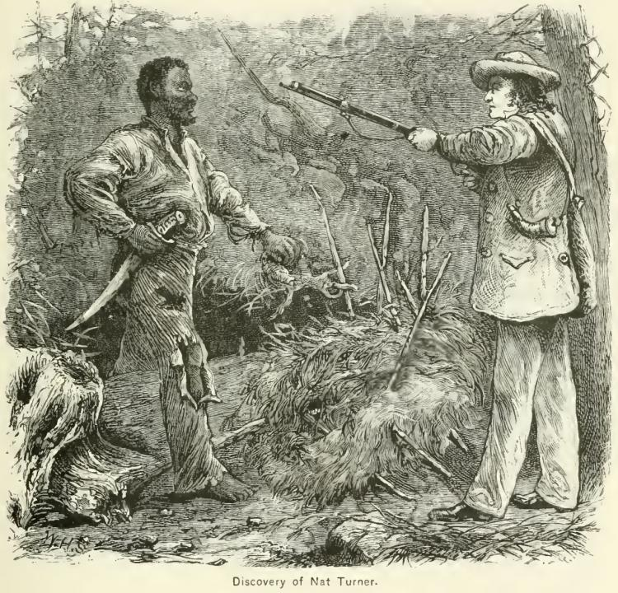
Nat Turner was an African American slave. In 1831, Nat Turner was sold to a craftsman named Joseph Travis. Around that time, an eclipse of the sun caused Turner to believe that the hour to strike for freedom was near. His plan was to capture the armory at Jerusalem, gather recruits, and hide out in the Dismal Swamp. Turner hoped to gather enough recruits to fight and win freedom for many or all slaves. On the night of August 21, Turner and seven fellow slaves launched a revolt. They murdered Travis and his family in their sleep and then set forth on a bloody march toward Jerusalem. In two days and nights about 60 white people were slain. Turner’s insurrection saw 75 blacks rally to the cause. Armed resistance from the local whites and the arrival of the state militia—a total force of 3,000 men—finally crushed the revolt. The slaves were either killed or captured. In the chaos, many innocent slaves were massacred. Turner avoided his pursuers for six weeks but was finally captured, tried, and hanged.

Nationalist or Terrorist? Why?

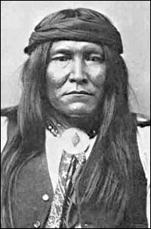
Cochise
Beginning with the arrival of Europeans in the 1500s, America was a constant battle ground. It is hard to imagine how many tribes of Native Americans were weakened or exterminated by the centuries of warfare with the European colonists. Cochise was a Chiricahua Apache chief famous for his string of revolts against the American and Mexican rulers who had taken over his lands. Cochise fought an 11 year war to stop the invaders from taking his land. Those 11 years of relentless warfare left southern Arizona a mostly burned-out wasteland—American and Mexican towns were destroyed. The death toll may have reached as many as 5,000 settlers and travelers—though many historians believe this number is an extreme exaggeration, that the toll was more likely a few hundred. Cochise’s band of warriors eventually were driven into the mountains and made peace without achieving their goal.
Nationalist or Terrorist? Why?

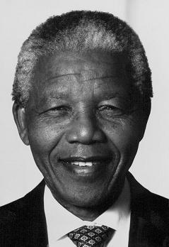
Nelson Mandela grew up in South Africa. In South Africa, the 90% black majority was ruled by the 10% white minority. In his early days Mandela was active in various anti-apartheid groups that pursued equal rights for black people in his native South Africa. Some of his early work involved bombings and acts of sabotage. Some people were killed in these acts. Mandela was eventually arrested. He was sentenced to Robben Island Prison and spent 27 years behind bars as a result of his ‘treason.’ Eventually, he was released and was elected President of South Africa.
Nationalist or Terrorist? Why?

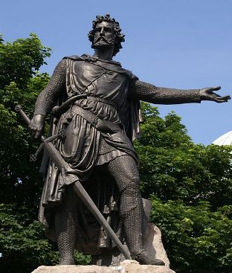
William Wallace was a landowner and noble who became a main figure in the war for Scottish independence. He was been made famous by works of art and literature and the 1995 film ‘Braveheart.’ By some accounts, Wallace was (partly) responsible for the start of the Scottish war for independence. This war saw the death of thousands. During the war, Wallace won several victories but was eventually captured. He was then executed by hanging. Next, his body was drawn and quartered- with the four parts of his body sent to various parts of the country to be displayed as a warning.
Nationalist or Terrorist? Why?

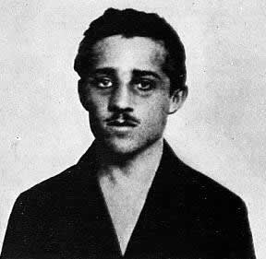
Gavrilo Princip

On October 6, 1908, Austria annexed Bosnia and Herzegovina directly into the Austro-Hungarian empire. Serbians who lived in Bosnia and Herzegovina were very upset. They wanted to be part of the country of Serbia. A secret organization called the Black Hand was set up. The Black Hand’s goal was to for Serbs to be ruled by Serbs. To accomplish this goal, the Black Hand performed various acts of sabotage and assassination. On June 28, 1914, Franz Ferdinand and his pregnant wife Sophie visited Sarajevo—the capital of Bosnia. Franz Ferdinand was the heir to the Austro-Hungarian empire—he was next in line to become Emperor. The Black Hand sent 7 assassins to Sarajevo to kill Ferdinand. One of the assassins was 19 year old Gavrilo Princip. Franz Ferdinand’s car drove by the first assassin—he did nothing. The second assassin threw a bomb at the car. It bounced off the car and exploded behind the car. The car continued on, passed several other assassins with no more attacks. Ferdinand’s car stopped and visited with the Mayor of Sarajevo. Then, the car continued on. It took a wrong turn and stopped to turn around in front of Gavrilo Princip—one of the assassins. Princip drew a gun and fired twice. His shots killed Franz Ferdinand and Sophie. Princip tried to kill himself with his gun and cyanide but was captured by the police. He later died in prison.
Nationalist or Terrorist? Why?
ENTANGLING ALLIANCES
Do Now Activity: Have students write a journal on this prompt: Does having friends tend to prevent arguments/fights or cause you to be involved in more arguments/fights?
Procedures: Have students stand in a large circle. Hand two balls—one red and one blue—to two different students. Have each student hold onto the end of the string while tossing the ball to a classmate. Have that classmate keep hold of the string while tossing it to a third, and so on until all students are holding a string. You should end up with a spider web of connections. Inform students that each string represents an alliance system. Discuss what an alliance system is, whether an alliance system would be beneficial in the case of a fight, and whether an alliance system would help cause or prevent a fight.
After discussion, collect your yarn and hang a name sign on three red yarn students. On one side of the name tag, put the made up students name. On the other side, put the nation. The red yarn students should be Germany, Austria, & Ottoman Empire. The blue yarn students should be Britain, France, Russia, Isaac, and Serbia. Read the bold section of the following situation—substitute in student names for the nations. If you have students who can handle it, students can mime (no talking) the action as you read. Read through the section again using country names instead of students. After examining the role play, ask students if they think a fight would have started if Steve had bumped into Alan and no one else had been around? Discuss how the friendships/alliances contributed to the fight and how they made the fight larger.

Gary (Germany), Alan (Austria) and Isaac (Italy) are standing together in the middle of the cafeteria when Steve (Serbia) bumps into Alan (Austria) and spills Alan’s (Austria's) milk. Alan (Austria) demands that Steve (Serbia) buy it a complete new suit because some of the milk splashed on the leg of Alan’s (Austria’s) pants. Gary (Germany) agrees with Alan (Austria). Bob (Britain) recommends that everyone calm down a bit.
Steve (Serbia) says that he can't afford a whole new suit but offers to pay for the cleaning of Alan’s (Austria's) pants. Rusty (Russia) and Steve (Serbia) look at Alan (Austria). Alan (Austria) asks Steve (Serbia), “ What are you looking at!!!????!!” Rusty (Russia) jumps in and tells Alan (Austria) to leave his little brother Steve (Serbia) alone. Alan (Austria) asks “Who is going to make me? YOU?!?!” Gary (Germany) shouts at Bob (Britain) and Frank (France) telling them to “Stop looking at me!” Bob (Britain) replies, “Frank (France) and I can look wherever we want to. Right now, we are looking at you, Gary (Germany). What are you going to do about it?”
Gary (Germany) tells Rusty (Russia), “Stop looking at Alan (Austria), or I am going to knock you into next week.” Bob (Britain) and Frank (France) tells Gary (Germany) to stop staring at their friend Bill (Belgium). Otto (Ottoman Empire) and Gary (Germany) go off into a corner and whisper. When they come back, Otto (Ottoman Empire) makes a show of not looking at anyone. Gary (Germany) rolls up its sleeves, looks at Frank (France), and punches Bill (Belgium). Frank (France) and Bob (Britain) punch Gary (Germany). Alan (Austria) punches Rusty (Russia). Gary (Germany) punches Bob (Britain) and Frank (France) with one hand and Rusty (Russia) with the other.

After examining the previous roleplay, ask students if they think a fight would have started if Steve had bumped into Alan and no one else had been around? Discuss how the friendships/alliances contributed to the fight and how they made the fight larger.
Rusty (Russia) throws a punch at Gary (Germany), but misses and nearly falls over. Johnny (Japan) calls over from the other side of the room that it's on Bob’s (Britain’s) side, but stays out of the fight. Isaac (Italy) surprises everyone by punching Alan (Austria).
Alex (Australia) punches Otto (Ottoman Empire), and gets punched back. There are no hard feelings because Bob (Britain) made Alex (Australia) do it. Frank (France) gets thrown through a plate glass window, but gets back up and carries on fighting. Rusty (Russia) gets thrown through another one, gets knocked out, suffers brain damage, and wakes up with a complete personality change. Isaac (Italy) throws a punch at Alan (Austria) and misses, but Alan (Austria) falls over anyway.
Isaac (Italy) raises both fists in the air and runs round the room chanting. America waits till Gary (Germany) is about to fall over from sustained punching from Britain and Frank (France), then walks over and smashes it with a barstool, then pretends it won the fight all by itself. By now all the chairs are broken and the big mirror over the bar is shattered. Bob (Britain), Frank (France) and America agree that Gary (Germany) threw the first punch, so the whole thing is Gary’s (Germany’s) fault. While Gary (Germany) is still unconscious, they go through its pockets, steal its wallet, and buy lunch for all their friends

Militarism Lesson
Procedures: In groups, have students read the Butter Battle Book by Dr. Seuss. As they read, have students complete side one of the Butter Battle worksheet. Discuss student answers to side one of the worksheet. After discussion, have students respond to the essay prompt and short answer question on side two. After giving time for writing and thought, share relevant WWI statistics on the buildup of armies and navies. Discuss student responses.
From http://alphahistory.com/worldwar1/militarism/
The arms race It is natural for military leaders to be obsessed with modernising their forces and equipping them with new technology, and the decades prior to 1914 saw no shortage of this. One of the most significant developments were marked improvements in the calibre, range, accuracy and portability of heavy artillery. This would allow artillery shelling and bombardments to become standard practice, particularly after the emergence of trench warfare. Machine-guns, first developed in 1881, became smaller, lighter, more accurate, more reliable and much faster (some were capable of firing up to 600 rounds per minute). Millions of metres of barbed wire, an invention of the 1860s, would be mass produced and installed around trenches to halt charging infantry. Various types of poison gas – chlorine, phosgene and mustard – were developed. On the oceans, the development of the dreadnought – a large battleship, the first of which was launched in 1906 – prompted a flurry of ship-building and naval rearmament. “The belief in war as a test of national power and a proof of national superiority added a scientific base to the cult of patriotism… In Britain, a real effort was made to teach boys that success in war depended upon the patriotism and military spirit of the nation, and that preparation for war would strengthen ‘manly virtue’ and ‘patriotic ardour’.” Zara Steiner, historian European military expenditure skyrocketed between 1900 and 1914. In 1870 the combined military spending of the six great powers (Britain, France, Germany, Austria-Hungary, Russia and Italy) totalled 94 million pounds. By 1914 this had quadrupled to 398 million pounds. German defence spending during this period increased by a massive 73 per cent, dwarfing the increases in France (10 per cent) and Britain (13 per cent). Russian defence spending also grew by more than one-third. Its embarrassing defeat in the Russo-Japanese War (1904-5) prompted the tsar to order a massive rearmament program. By the 1910s, 45 per cent of Russian government spending was allocated to the armed forces, while just five per cent went on education. Every European power but Britain increased conscription levels to bolster the size of their armies. Germany alone added 170,000 full-time soldiers to its army in 1913-14. Germany also dramatically increased its navy: in 1898 the German government, largely at the kaiser’s behest, ordered the construction of 17 new vessels. The Germans also pioneered the construction of military submarines: by 1914 the Kaiser’s navy had 29 operational U-boats. These developments caused alarm in Britain, and London responded by commissioning 29 new ships for the Royal Navy.

What is the source of disagreement between the Yooks and the Zooks?

The Yook grandfather starts off with a _____________________________ as a weapon. Then a Zook gets a ___________________________________. That starts something we could call “militarism” or an arms race—a battle to see who can build the best weapons—as the Zooks and Yooks try to one up each other.
The next weapon is a ______________________________________.
Then a ________________________________________.
Then a ________________________________________.
Then a ________________________________________.
Then a ________________________________________.
Then a ________________________________________.
Then a ________________________________________.

As the Zooks and Yooks tried to “one up” one another, was war more or less likely?

What do you think happens in the end? Explain your answer in at least one paragraph.

COLONIALISM
In groups of 4-5, work through the following simulation. One person in each group should be Britain, one France, one Portugal and Spain, one Germany, and one Italy. Follow directions on the handout and be sure to look at your maps before you make decisions. After finishing, use your brain to help answer these questions.
What nation was described as being the strongest nation in the world during this time?

What nation got the best deal as Africa was divided up?

How would the other nations have felt about this?

Based on the descriptions, which nation do you think would have been least happy with the results of splitting Africa up?
Do you see any way in which the actions of these countries could lead to a war? Explain!

COLONIALISM
In groups of 4-5, work through the following simulation. One person in each group should be Britain, one France, one Portugal and Spain, one Germany, and one Italy. Follow directions on the handout and be sure to look at your maps before you make decisions. After finishing, use your brain to help answer these questions.
What nation was described as being the strongest nation in the world during this time?

What nation got the best deal as Africa was divided up?

How would the other nations have felt about this?

Based on the descriptions, which nation do you think would have been least happy with the results of splitting Africa up?
Do you see any way in which the actions of these countries could lead to a war? Explain!

One person will be Britain, one will be France, a third person will be Portugal, Belgium and Spain. The fourth person will be Germany, and Italy.
ROUND 1 (1500 to 1815): Portugal - You are the first to explore the coast of Africa. Color six brown boxes on the map to signify the locations where you establish your facilities.

Britain and France - At first, you aren't very interested in Africa but do begin some small settlements. Britain colors four red boxes and France colors 4 blue boxes at different locations on the ocean so that you can easily trade. Britain and France alternate placing their boxes with Britain going first and each can take one Portuguese port if they choose to do so.

ROUND 2 (1815 to 1875): Portugal - You are becoming more interested in trade with Africans so you expand your influence around your ports. Color a 4 boxes around each of the ports you have left.

Britain and France - You are experiencing the Industrial Revolution--that means you have more and more factories in your countries. You are now more interested in Africa for its natural resources and as a place to sell your goods. Since you want to avoid angering other countries, you will not take territory too close to that of another European country. Britain and France take turns coloring clusters of 5 boxes each. The territory does not have to be near land you already own but does need to be on the coast. Consider areas with big populations, good natural resources, and places where transportation might be easy.

ROUND 3 (1875 to 1895): Britain - You are the most powerful country in the world at this point. Color in seven boxes that you would like to add to your territory.

Belgium - You came into the race late because you are a small country which only got its independence in 1830. However, you have many factories and want African natural resources. Your weakness as a power will restrict you to only one colony but if you act fast you can grab some valuable territory before the major powers catch on. Color a 7 box area that is not already claimed. Your color is green.

Germany - You came into the game late because you were not even a unified country until 1871. You have emerged as the major military power in Europe, you are very industrialized and you are interested in developing your world trade. You desire African colonies for their natural resources and for people to market your goods to. Your pride as a major power demands that you have colonies like the other major powers and that upstart Belgium has just grabbed a chunk of territory. You had better act fast. Your color is orange. Color three areas--each four boxes in size.

Britain and France - Whoa! Where did these newcomers come from gobbling up territory. If we don't act fast they will take territory we want. We would like to link up our scattered colonies so that we can build railroads for better transportation of the natural resources. Britain and France take turns choosing four areas. Each area will be four boxes in size.

Spain - You have come to Africa later than the other major colonizers because you have spent most of your earlier efforts in Central and South America. You are a weak country which is primarily interested in areas that would be close to Spain (in the far northern part of Africa). Your color is purple. Color two areas--each 4 boxes in size--that are not already acquired.

Italy - You come into the race last and have to take what is left. Color four areas (each area can be four boxes in size) not already taken. Your color is yellow.
