**LINCOLN – DOUGLAS DEBATES**

**1858**

TEAM: _________________________

Use your textbook/internet resources

|  |  |
| --- | --- |
| **ABRAHAM LINCOLN** | **STEPHEN DOUGLAS** |
| http://www.andyamato.com/images/lin%20doug%20web%202.jpg |  |

**Fact Bank**

“Little Giant” Born in Kentucky

Believed that slavery was morally wrong Incumbent Senator (running for re-election)

Democrat Relatively unknown in political circles

Promoted Popular Sovereignty Successful Lawyer

Republican No easy way to eliminate slavery

1. **What political groups joined to form the Republican Party in 1854 and what was the main message of the Republican Party?**
2. 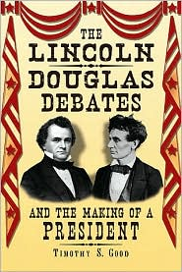**What did Lincoln say about slavery that already existed and about whether slavery should spread or not?**
3. **What was the Freeport Doctrine?**
4. **What did Douglas claim about Lincoln’s views of African Americans?**
5. **What did Lincoln say the real issue was?**